Jordan Whittington and Adam Boenhlein

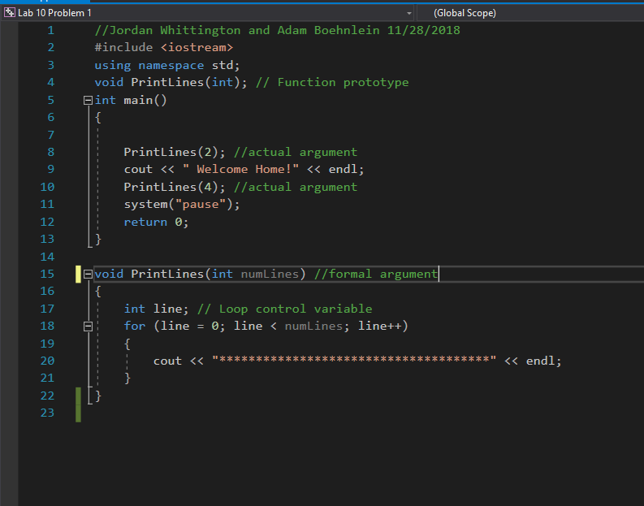

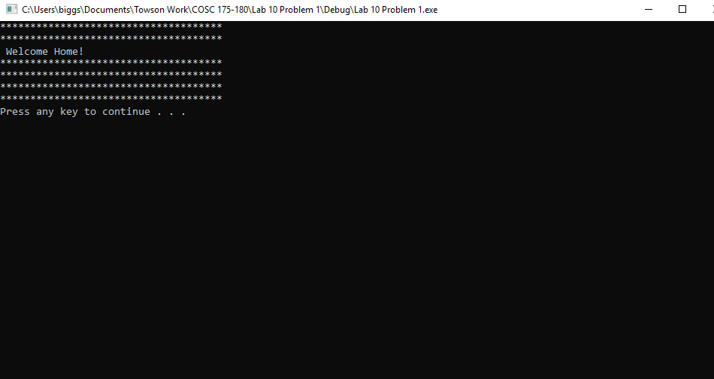

2.PrintLines is a void function because it is a standalone function.

3.numLines is being passed in

Program 2:

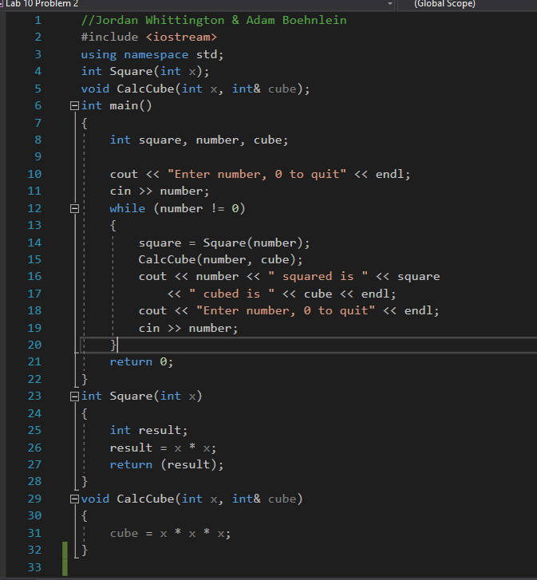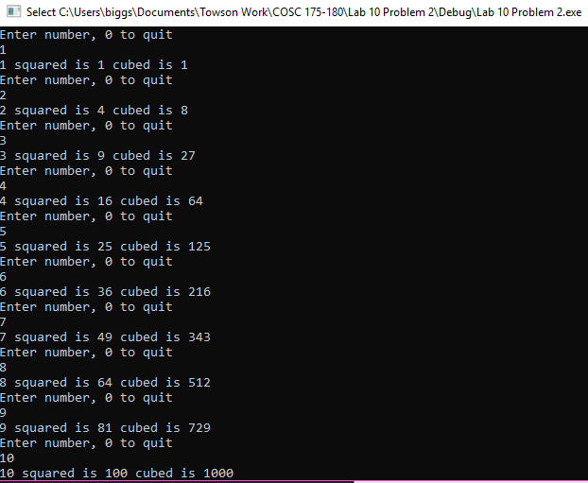

Problem 3:

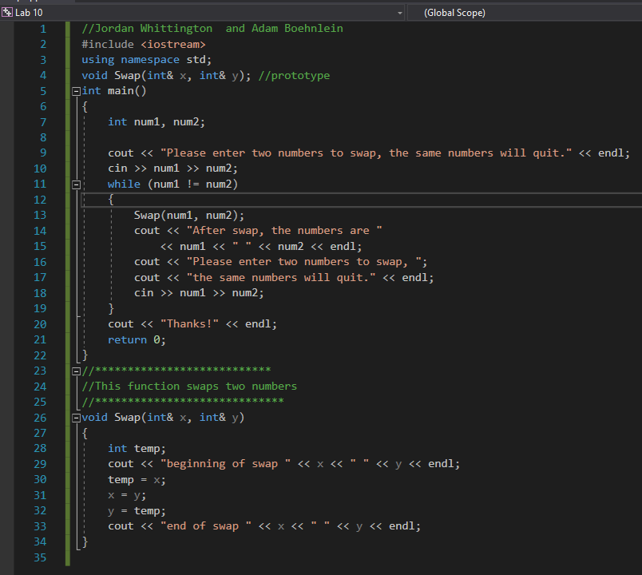

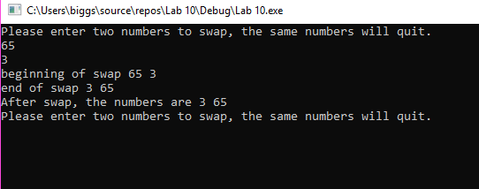

2. The numbers are being swapped within the function, but the new numbers are not being distributed back out of the function, so you would need to include the ampersand symbol in the function after each int but before the variables so that the swapped values are passed out of the function.